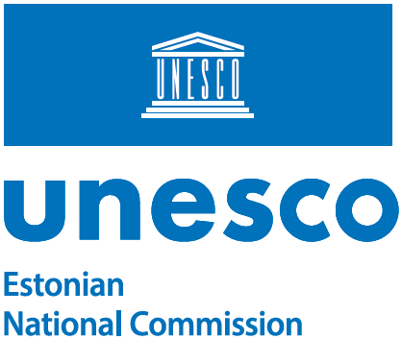

l.ruprecht@unesco.org |  |  | 14.05.2025 | No 14-3/11-1

Dear Ms Lydia Ruprecht,

Hereby, I kindly inform you that in Estonia, Ms Velli Racioppi has been appointed UNESCO Associated Schools Network national coordinator, succeeding Ms Meelike Terasmaa.

Please note the contact information for the ASPnet in Estonia:

Ms Velli RACIOPPI
NGO Mondo
Telliskivi 60A, B-hoone, 10412 TALLINN, ESTONIA
Tel +372 677 5445
Email unescoschools@mondo.org.ee

Yours sincerely,

Kerli Gutman-Normak

Secretary-General
Estonian National Commission for UNESCO

Madli Kumpas +372 6441431
Madli.Kumpas@kul.ee

